

IVAO - XO

# ATC Ops Manual

# Adelaide ADC

# *YPAD_TWR*

# *YPAD_GND*

|  |  |
| --- | --- |
| Written by | AOAC Charlie Walton |
| Controlled by | ATC Operations Department |
| Date | *12/06/2024* |
| Amendments |  |

# *YPAD_DEL*

### Airport Information

|  |  |
| --- | --- |
| Information | |
| ICAO Code | YPAD |
| IATA Code | ADL |
| Airport name | *Adelaide Airport* |
| Time zone conversion | UTC +9:30 |
| Permitted traffic types | IFR / VFR |
| Runways | 05/23, 12/30 |

### Aerodrome Control Positions

|  |  |  |  |
| --- | --- | --- | --- |
| Logon: | Callsign | Frequency | FRA |
| YPAD_TWR | Adelaide Tower | 120.500MHz |  |
| YPAD_GND | Adelaide Ground | 121.700MHz |  |
| YPAD_DEL | Adelaide Delivery | 121.600MHz |  |

1. YPAD_TWR is the standard position for Adelaide ADC. This position shall be opened first, and can be opened any time.
2. YPAD_GND is the only ground position for Adelaide. This position shall be opened only once YPAD_TWR is online.
3. YPAD_DEL is the clearance delivery position for Adelaide. This position shall be opened only once YPAD_TWR and YPAD_GND are online.

### Responsibilities

Adelaide Tower is responsible for the class C Adelaide CTR (SFC-1500ft). Tower are also responsible for both runways, the helipad, helicopter training areas and taxiways E and D. Ground are responsible for the remainder of the maneuvering area. Traffic looking to cross runway 12/30 at E1, or 05/23 at D1 will be instructed to ‘hold at (holding point), contact Tower on 120.5’ prior to being given a crossing clearance by Tower. Aircraft vacating runway 12/30 on D2 or 05/23 on E2 will be instructed to ‘cross runway (number) hold short of taxiway A’, and then transferred to Ground for onward taxi instructions.

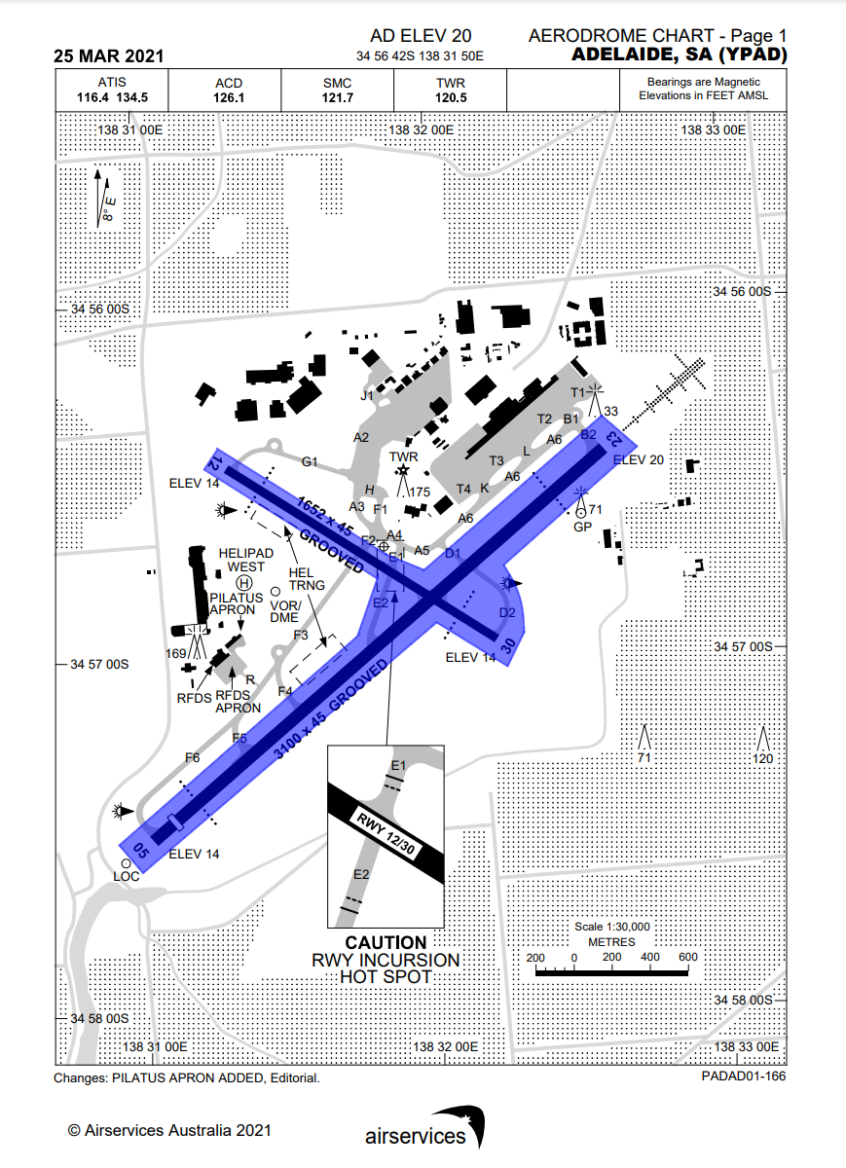

*Image from AIP Sept 2023. Uncontrolled.*

*Blue – YPAD_TWR*

### Tower

### Runway Selection

Adelaide ordinarily operates on a single runway. Due to the length of both runways, this will normally be 05/23. The cross runway may be used as operationally required.

Adelaide routinely utilises curfew operations (runway 05 for arrivals, 23 for departures) overnight for noise abatement purposes, subject to traffic levels and meteorological conditions. This is at the discretion of the Tower controller.

### Auto Release

Auto Release applies at Adelaide for aircraft:

* Assigned a procedural SID from a runway nominated on the ATIS and;
* Assigned the standard assignable level

All other departures require a release from Departures, via a ‘Next’ call.

Auto Release does not apply to:

* VFR departures
* Aircraft assigned the radar SID
* Departures to aerodromes within the Adelaide TCU
* High performance jet departures
* All departures during Curfew nomination

Additionally, Tower will coordinate the following with Departures:

* Go arounds/missed approach

### Circuits

Circuits are authorised to the east of the aerodrome on runway 05/23, and to the south of runway 12/30.

At no point are circuits to be authorised when cross runway operations or curfew nomination are being used.

### Transfer to Departures

The frequency for departures will follow this priority order:

North West:

**Runway 05: Runway 23:**

YPAD_NW_APP YPAD_NW_APP

YPAD_APP YPAD_APP

YMME_AD_CTR YMME_AD_CTR

YMME_CTR YMME_CTR

South East:

**Runway 05: Runway 23:**

YPAD_SE_APP YPAD_SE_APP

YPAD_APP YPAD_APP

YMME_AD_CTR YMME_AD_CTR

YMME_CTR YMME_CTR

All:

**Runway 12: Runway 30:**

YPAD_SE_DEP YPAD_NW_DEP

YPAD_APP YPAD_APP

YMME_AD_CTR YMME_AD_CTR

YMME_CTR YMME_CTR

The Adelaide Approach airspace is split along the Runway 05/23 centreline, therefore an easy way to know which frequency to send departures to is to see whether the SID terminus is left or right of the climb out.

### Helicopters

Tower will issue helicopters using the helipad takeoff/landing clearances. Tower will need to coordinate with ground before authorising helicopters to cross taxiway F to the southern training area.

### Ground

### Runway Release

When runway 12/30 is not in use, ground may request a release of the runway. In this case the runway is owned by ground, and ground do not need to coordinate runway crossing, backtracks, or taxiing on 12 or 30. The same principle applies when runway 05/23 is not in use.

### Aircraft Bay Assignments

|  |  |
| --- | --- |
| Stand | Airlines |
| 10A-D | RXA props |
| 50A-G | QLK |
| 12-29 | *All jet airliners* |
| 80-88 | *Cargo* |
| General Aviation | *Business Jets, GA, maintenance* |
| RFDS Apron | FD (RFDS) |
| Pilatus Apron | *On Request* |

### Transfer to Tower

In real life, Australian operated aircraft will usually transfer to Tower without instruction, however due to the nature of IVAO this cannot always be expected, therefore Ground must transfer all aircraft to Tower when practical (no further ground traffic to effect). Reference the responsibility section. Where a runway is released to Ground, Ground will instruct aircraft to cross the inactive runway BEFORE transferring to Tower.

### Delivery

### Coordination

Delivery is responsible for coordinating where required with the relevant Approach controller, prior to giving clearances involving the following:

* Departure from a runway not included on the ATIS.
* Non-standard requests
* High performance jet departures

The Approach controller may then issue instructions including a routing, heading, or altitude constraint, which must be passed on in the clearance.

### Standard Assignable Level

Clearance Delivery are responsible for assigning an initial climb in the clearance. Unless otherwise coordinated between Delivery and Departures, this shall be:

Jets: 5000ft, or the requested RFL, whichever is lower.

Props: 4000ft, or the requested RFL, whichever is lower.

### SID Assignment

Where able, all IFR jets should be assigned the procedural SID which terminates at the appropriate waypoint according to their flight plan, or rerouted via the most appropriate SID according to runway in use and direction of flight.

IFR prop aircraft, and IFR aircraft unable to accept the procedural SID will be assigned the AD radar SID.